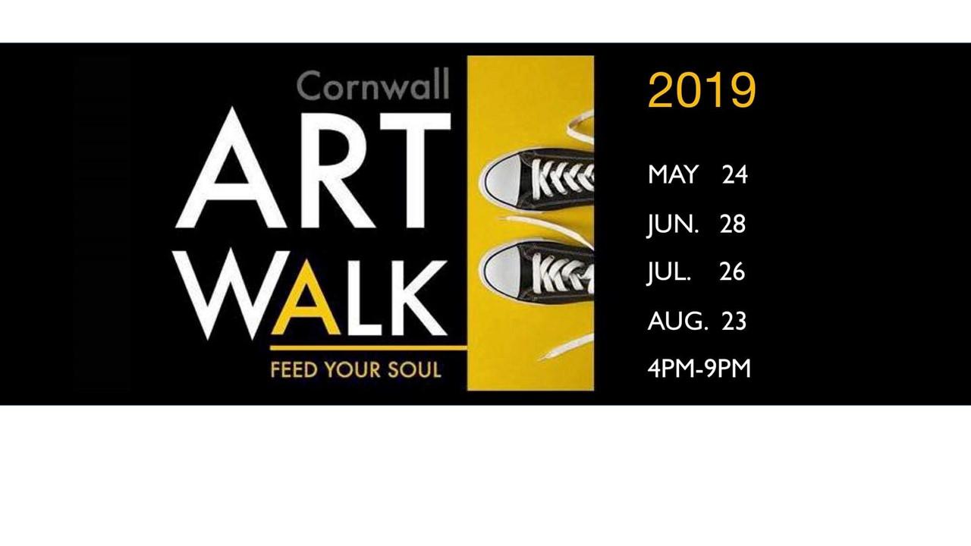
ART WALK 2019
CALL TO ARTISTS
Fourth Friday of May, June, July and August from 4pm to 9pm

Art Walk is a monthly event in downtown Cornwall when artists display their art in store windows and on the walls of local businesses on the fourth Friday of May, June, July and August from 4pm to 9pm. Artists are present to paint and draw during the evening and talk to people about their art. Art Walk showcases visual artists and performing artists (dancers, musicians and thespians) in various places while merchants participate with sidewalk sales and some restaurants with specials on the menu.

Artists are invited to apply for a space in the downtown area for one or more of these dates. Because there is a limit of sites available, spaces will be allocated on a first come, first serve basis.

Artists will be assigned a site with possible rotation each month determined by a small group of volunteer organizers. There is neither fee nor commission to be paid for participating.

Publicity will be done through social media, Cornwall Tourism, Cornwall website as well as other appropriate venues. There will be posters and or flags indicating the sites; a passport /map will be made available to visitors at all the places.

Artists are responsible for their equipment, supplies and shelter if so desired. Some sites have no access to electricity or water. Respect for set up time and presence is crucial. If art is to be displayed in a window or business place, it should be done earlier in the day of the Art Walk and arrangements made with the owner of the business for take down.

If the artist is a performer, a schedule will be included in the passport / map indicating the times and locations. All artists are asked to respect their commitment. All participation is at the artist’s own risk.

Please fill in the information on the Application Form and indicate your availability.
Applications must be returned by April 30th, 2019 to: Art Walk, Benson Centre, 800 Seventh Street West, PO Box 8, Cornwall, ON, K6J 0A3. or copied, filled in and emailed to Virginia Lake at vmnlake@gmail.com .

** Performing artists, contact Jane Macmillan (jbmacmil@primus.ca ) and
Visual artists, contact Linda Geisel lindageisel@gmail.com for more information.

ART WALK
APPLICATION FORM
Fourth Friday of May, June, July and August from 4pm to 9pm

VISUAL ARTIST
Name: (Individual or group)
(If you are a group please give contact information of the leader)
Phone number:
Email:
Space requested (please check all that applies)
- Window space
- Sidewalk space
Date s:
- May 24
- June 28
- July 26
- August 23

PERFORMING ARTIST
Name: (Individual or group)
(If a group, please give the contact information of the leader)
Phone number:
Email:
Discipline:
- Dance: category:
- Music: category:
- Other performance: category:
Requirements:
- Electricity (limited availability)
- Smooth surface for dance
- Shelter
- Other
Because 5 hours is too long for a performance, we suggest choosing one or more half- hour time slots. Performer could always arrange to extent the time slot.
Please circle all the times that apply.

*4pm *4:30 *5pm *5:30 *6pm *6:30 *7pm *7:30 *8pm *8:30

All accepted artists will receive an email indicating the date, site and time of their participation by May 17thfor the May 24th Art Walk. Artists will also be advised if there is insufficient or inappropriate space to accommodate them. All applications will be kept for the subsequent events.
Artists also have the opportunity to apply at the later dates for the June, July and August Art Walk. However, space will be limited as space is assigned on a first-come first-serve basis.

